**DAILY ASSESSMENT FORMAT**

|  |  |  |  |
| --- | --- | --- | --- |
| **Date:** | **16/07/2020** | **Name:** | **Yashaswini.R** |
| **Course:** | **Mathematics for machine learning: Linear Algebra** | **USN:** | **4AL17EC098** |
| **Topic:** | **Matrices, vectors, and solving simultaneous equation problems** | **Sem &Sec:** | **6th sem ‘B’ sec** |
| **Github Repository:** | **Yashaswini** |  |  |

|  |
| --- |
| **FORENOON SESSION DETAILS** |

**IMAGE OF SESSION**

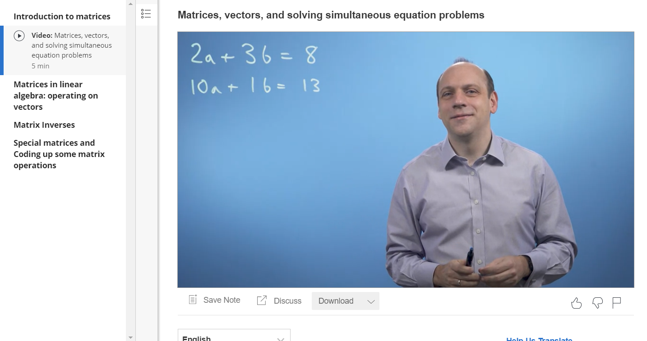

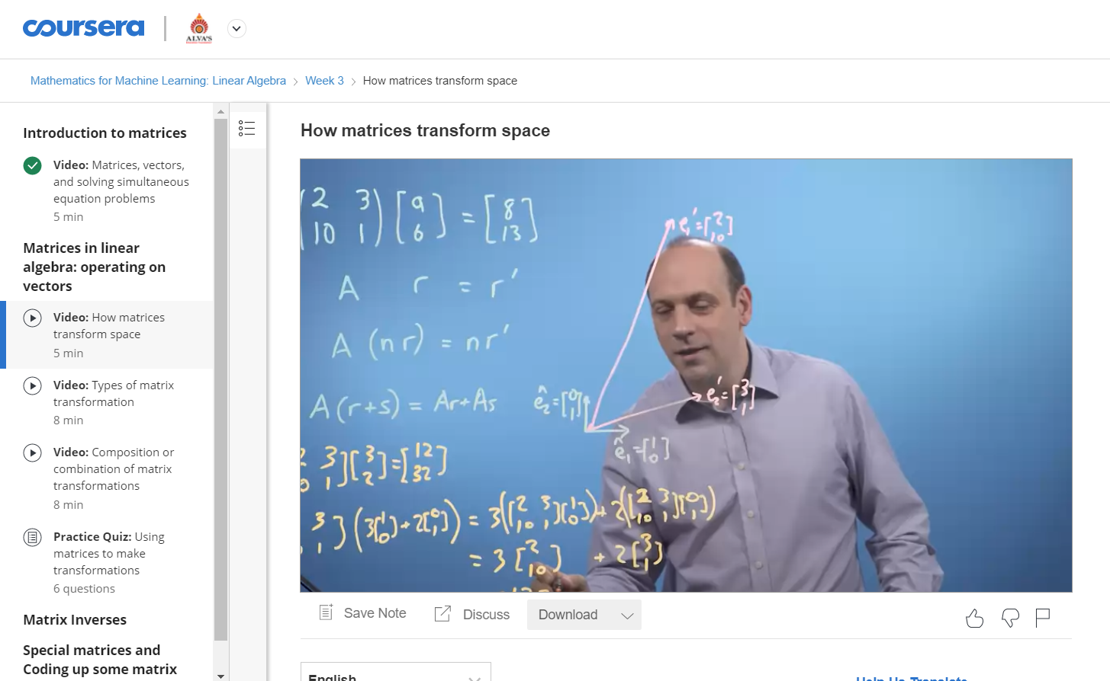

* Matrices are classified according to the number of rows andcolumns, and the specific elements therein.

Row Matrix: Amatrix which has exactly one row is called a row matrix.

The above two matrices are row matrices because each has only one row.

* Matrices are a useful way to represent, manipulate and studylinear maps between finite dimensional vector spaces (if youhave chosen basics)
* The series primarily consists of a trilogy of science fictionaction films beginning with The Matrix (1999) and continuingwith two sequels.
* The Matrix Reloaded and MatrixRevolutions (both in 2003), all written and directed by theWachowskis and produced by JoelSilver.
* The term matrix was introduced by the 19th-century EnglishmathematicianJames Sylvester, but itwas hisfriend themathematician Arthur Cayley who developed the algebraicaspect of matrices in two papers in the 1850s.
* In biology, matrix is the material (or tissue) in animal or plant.
* Structure of connective tissues is an extracellular matrix.
* It isfound in various connective tissue.
* It is generallyused as a jelly like structure instead of cytoplasm in connectivetissue.
* Bone matrixissynthesized by alayer ofosteoblasts on the bone surface
* Theosteoblasts are mesenchymal in origin and characterized bytheir abundant endoplasmic reticulum and their production ofthe enzyme alkaline phosphatase.
* In the mitochondrion, the matrix is the space within the innermembrane.
* The word "matrix" stems from the fact that thisspaceiscomparedtothe relativelyaqueouscytoplasm.
* The extracellular matrix (ECM) is the non-cellular componentpresent within all tissues and organs, and provides not onlyessential physical scaffolding for the cellularconstituentsbutalsoinitiatescrucialbiochemicalandbiomechanicalcuesthatarerequiredfortissuemorphogenesis,differentiation andhomeostasis.